Open Home Security Gateway User Manual v1.7.6.1

Contents

Preface
Open Home Security is an Arduino based Home Security system. Built by Adam Baron from Czech Republic. Refer to openhomescurity.blogspot.com for the blog and news. Refer to the blog for the link to the forum and ask any questions there.
All code is downloadable from Adam's github site or in the case of schematics and precompiled firmare from his google drive. See the blog for links to both.

Hardware
The gateway is a compact board that contains an Atmega1248p processor, WizNet W5500 network chip, RFM69 radio, SIM 800C GSM chip, RS485 bus, and Analog, Digital IO for the alarm sensors and sirens etc. Wiring diagrams are available on the blog site.

Programming
Configuration of OHS (Open Home Security) is done via its web interface. This is accessed via any web browser to the IP address of the gateway. The default user is '#' and password is '#'.

Common programming functions
Applying and saving the configuration changes made to a page is done by the buttons at the bottom. All pages have an apply and a save all. The only page with more buttons is the global page.
To save a setting in RAM use the apply button. Now you test your new settings. If you are happy then click save all and the changes are written to the EEPROM for permanent storage. If you are not happy with the changes you made, do not use save all and instead use the load last button on the global page to revert back to the settings stored the last time save all was used. Note that if you repower the gateway than any changes you have only applied and are not saved to EEPROM will be lost as the gateway will automatically load what is saved in the EEPROM.
Reset to default is used whenever there is major update to the OHS firmware. This is because the EEPROM data structure will have changed, and the new data structure will not read the data saved in the EEPROM correctly. Therefore reset to default will clear all data and the gateway wil need to be reprogrammed again from the start.
- Apply – Applies current configuration but does not save to EEPROM.
- Save All – Saves config to the EEPROM.
- Get NTP Time – Gets current NTP time from NTP server. GW waits for esponse only max. 4s.
- Load Last – Loads the last configuration saved in EEPROM. Use this to rollback to the last settings used if you have made changes and do not want to keep them.
- Reset to Default – Clears all user data in all pages and sets the gateway back to a blank device. Usually required for a major version update of the gateway.

Global Page
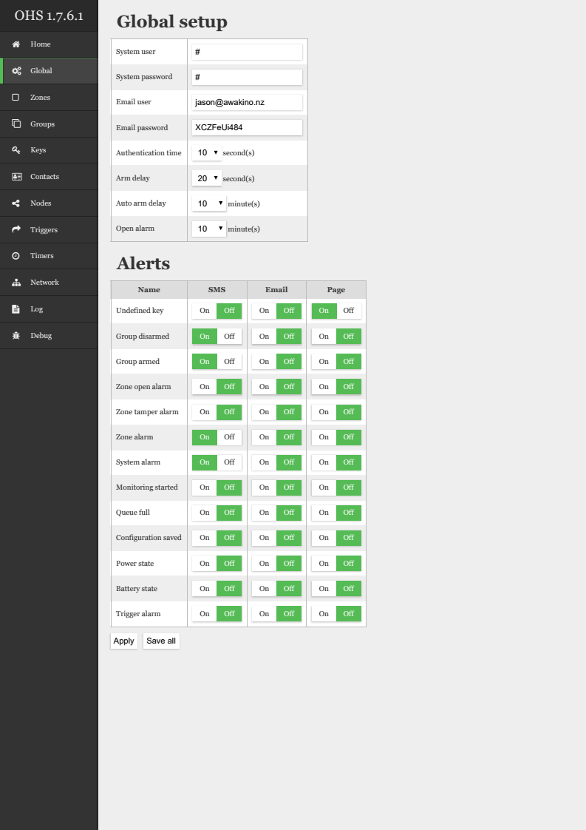
- System User – Login name of user – Default is '#'. note that is for the web interface only
- System Password - Login password – Default is '#'. note that is for the web interface only
- Email User – Email user name for email alerts. This is the user that the system will use to log in to smtp2go to send you email alerts. (Note that when you create the smtp2go account you will need to a create an app user for OHS to use)
- Email Password - Email password for email alerts. This is the password that the system will use to log in to smtp2go to send you email alerts. (Note that when you create the smtp2go account you will need to a create an app user for OHS to use)
- Authentication Time – Authentication time is base time for delay, that gives you time to authenticate and disarm group. It is further expanded by zone authentication time multiplier, and covered later in Zones setting.
- Arm Delay – The time that system will delay for after the iButton is presented at an authentication node, till it changes to the Armed state. The Delay period is indicated by the periodic beeping of the authentication node.
- Auto Arm Delay – The time that OHS will wait for without detecting any activations on any Alarm sensors before activating the Auto arm feature. Any triggering of a Alarm sensor during the delay time restarts the time period.
- Open Alarm – Open alarm is time base for another feature reminds you that zone is in alarm state for longer then specific time, ie door is opened for longer then 10 minues. This can be used if you have reed switch sensor on your back door or garage. Open alarm has to be enabled in specific zone as well, then gateway will notify you by SMS, email or page you.
- Alerts - Switch on any of SMS, Email, or Page to recieve alerts for any of the events below.
  - Undefined Key – sends an alert for a key that is badged at an authentication node but is not listed in the keys page.
  - Group Disarmed – sends an alert if any group is disarmed.
  - Group Armed – sends an alert if any group is armed.
  - Zone Open Alarm – sends an alert for any zone that is in open alarm state. The zone must be set to send an open alarm on the zone page.
  - Zone Tamper Alarm – sends an alert for any zone that is in Tamper state. The zone must be set to send a Tamper alarm on the zone page.
  - System Alarm – sends an alert for any system alarm.
  - Monitoring Started - Start of GW after power On.
  - Queue Full - One of software data queue is full. A signal to contact author.
  - Configuration Saved – Sends an alert whenever the Gateway configuration is saved.
  - Power State – sends an alert whenever the power supply connected to gateway loses the AC supply.
  - Battery State – sends an alert when that back battery gets low. Triggered by the battery input which is normally conneted to the battery backed up power supply.
  - Trigger Alarm – sends an alert whenever a trigger alarm occurs. Triggers are set up on the trigger page.

Home Page
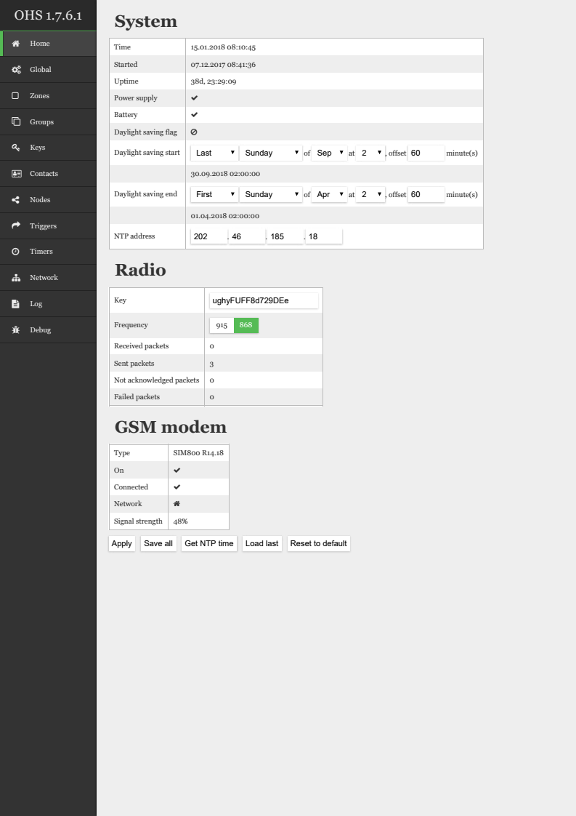
- System – useful system info including last start up time, power supply and battery states.
  - Daylight Saving start – set the daylight saving start date for your country here. ( note that is the logical day in the week of the month, which means it will calculate the correct actual date itself)
  - Daylight Saving end – set the daylight saving end date here.
  - NTP Address – insert an address for an NTP Server here. Easiest way to find one is to search for the ntp server for your country to find its host name. Then ping that host name in a terminal to obtain its actual ip address.
- Radio – Status and operational data of the RFM69 radio
  - Key – insert your own personal 16 Digit key here to encrypt the RFM69 radio traffic
  - Frequency – select the frequency for your RFM 69
  - Received Packets – packets received by the gateway
  - Sent Packets – packets sent by the gateway
  - Not Acknowledged Packets – Packet not ackowledged by node, caused by sleeping nodes. Packet are repeated normally.
  - Failed Packets – Packet not delivered by node, caused by sleeping nodes. No Need to panick if you have speeing nodes.
- GSM Modem – GSM Status and info
  - Type – GSM chip type
  - On – shows the GSM chip is active and connected
  - Connected – GSM is connected to the cellular network
  - Network – Statuses of GSM network: Home, Not registerd, roaming ...
  - Signal Strength – Cellular network strength in percentage
- Apply – applies current configuratio but doesnt save to EEPROM
- Save All – Saves config to the EEPROM
- Get NTP Time – Gets current NTP time from NTP server. May take a few?? mintes
- Load Last – Loads the last configuration saved in EEPROM. Use this to role back to the last settings used if you have made changes and do not want to keep them.
- Reset to Default – Clears all user data in all pages and sets the gateway back to a blank device. Usually required for a major version update of the gateway.

Zones
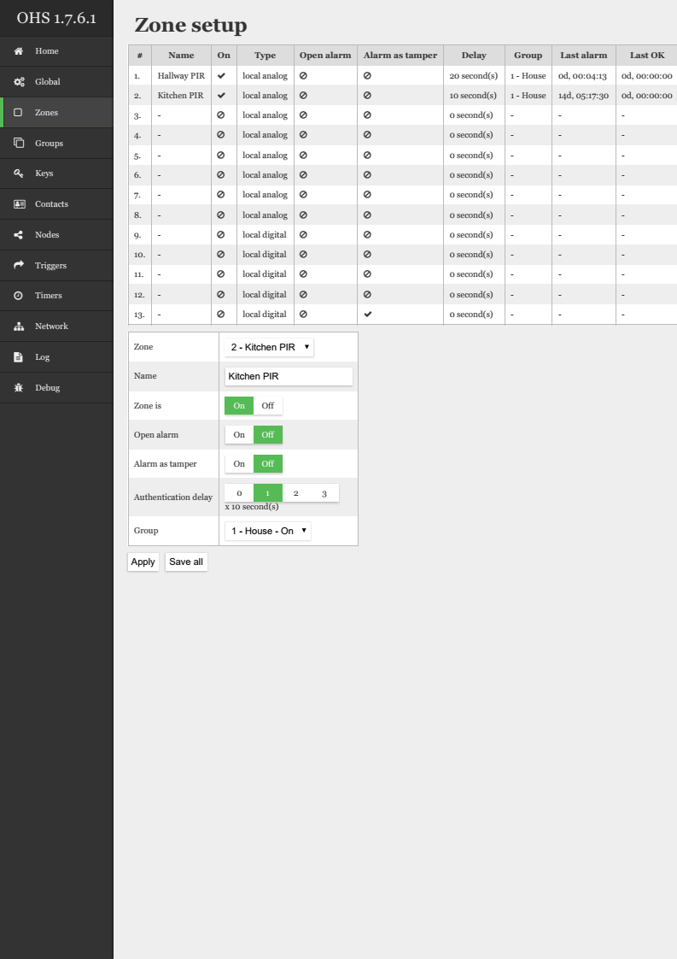
- Zone Setup - Table of all zones and there associatted data and status info. Configuration is done in the lower table. Zones are the individual sensors of the alarm. A total number of 50 zones can be configured. There are 13 zones on board the gateway, 8 analog and 5 digital. Additional zones can be added by hardwired RS485 or RFM69 Wireless nodes. Additional zones added by nodes are automatically added to the zones list.
  - Zone – select the zone you wish to configure in this list
  - Name – assign the zone a descriptive name
  - Zone is – switch the zone off or on here. This will need to be set to on for any alerts, mqtt publish to be made by this zone
  - Open alarm – Open alarm is enabling the zone to be monitored for long alarm state. Such feature reminds you that zone is in alarm state for longer then specific time. This can be used if you have reed switch sensor on your back door or garage and you keep it open.
  - Alarm as Tamper – Alarm as tamper forces the zone alarm state to tamper state, it is useful for digital zones, and is set by default for the enclosure tamper contact (zone 13).
  - Authentication Delay – Authentication delay is zone setting for authentication time multiplier for given zone. Put it simple is time that gateway waits when current zone is tripped. For entry door sensor you will set it to 1~3, based how much time you need to reach the authentication unit. For you window zone, or inner house PIR sensor you will set it to 0, no need to wait for authentication when someone enters your house through window.
  - Group – the group which the zone is assigned to. Group needs to be armed for a zone to open alarm. Tamper works even on disarmed grooup.

Groups
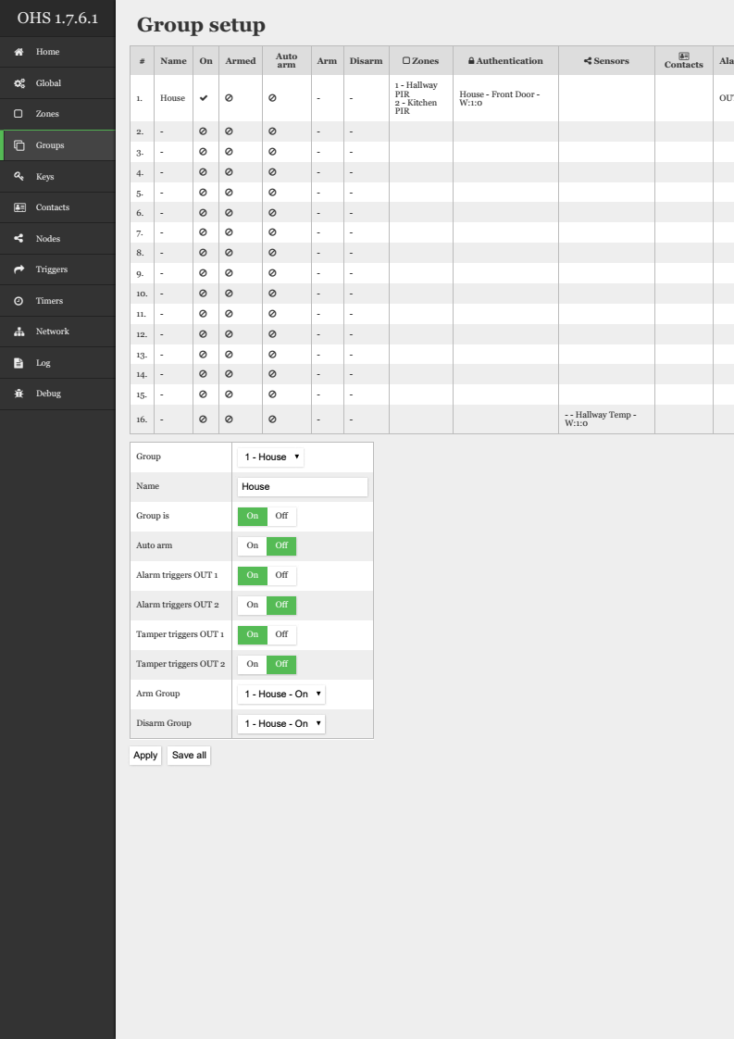
- Group Setup – group set up is where all the groups which manage zones and sensors are configured. A total of 16 groups are available. The main table shows all the group settings and info. Recent group events are also displayed. Groups can be controlled individually or mutliple groups controlled by assigning the arm and disarm or multiple groups to another group. The lower table is used for configuration.
  - Group – select the group to configure from this list.
  - Name – descriptive name of the group.
  - Group is – set the group on here to make the group active. This is not the arm or disarm but whether the group is to be used or not.
  - Auto Arm – set to on if you want the group to automatically arm. The group must have all zones closed for the duration of the auto arm time set on the global page to arm.
  - Alarm triggers OUT 1 – Any alarm triggered by an opening zone when the group is armed will trigger relay output 1 on the gateway
  - Alarm triggers OUT 2 – Any alarm triggered by an opening zone when the group is armed will trigger relay output 2 on the gateway
  - Tamper triggers OUT 1 – Any tamper triggered by a tampered zone will trigger relay output 1 on the gateway.
  - Tamper triggers OUT 2 – Any tamper triggered by a tampered zone will trigger relay output 2 on the gateway
  - Arm Group – select the master group to arm the the group being programmed. Not neccessary if the group is has authentication node directly assigned to it. This feature is for mutliple group arming by a master group. Here we might see 2 different meanings, put perhaps the same. chained arming or disarming. That is while arming/disarming one group manually with key, you can configure gateway to select another group to do the same. It can be useful, as shown on picture, to arm automatically Garage when you arm House group. This is set separately for arm and disarm, and groups can be chained. Even the chain can be made as circle, that is House -> Grage -> Barn -> House, this way anytime you arm one of these three groups all will become armed. When you do not need any chained group you leave it set to the same group. I would not sufggest a group without at least one authentication uinit.
  - Disarm Group – select the group to disarm the the group being programmed. Not neccessary if the group is has authentication node directly assigned to it. This feature is for mutliple group disarming by a master group. Same as above arm.

Keys
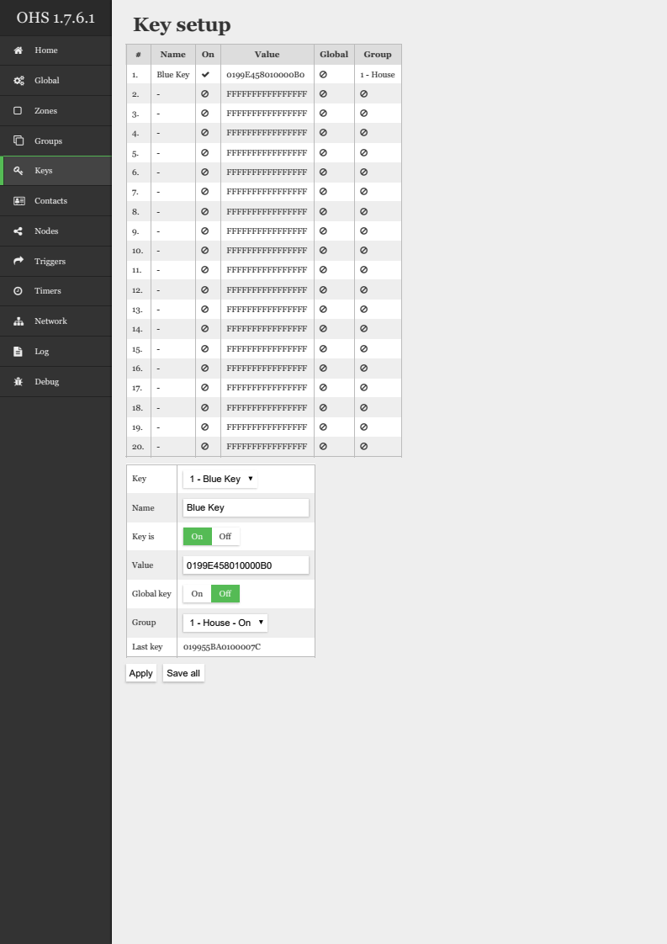
- Key Setup – set up the iButton authentication keys to arm and disarm groups here. A total of 20 keys can be programmed. Programming is done in the lower table
  - Key – select the key to program from the list.
  - Name – descriptive name of the key.
  - Key is – activate the key by switching to on.
  - Value – this is the unique code which belongs to the key. Can be found by badging a key at an authentication node and the value read from the last key field or the log page.
  - Global Key – set to on to make the arm and disarm any groups.
  - Group – select the group for the key to arm and disarm from the list.
  - Last Key – shows the data for the last unknown key badged at any authentication node.

Contacts
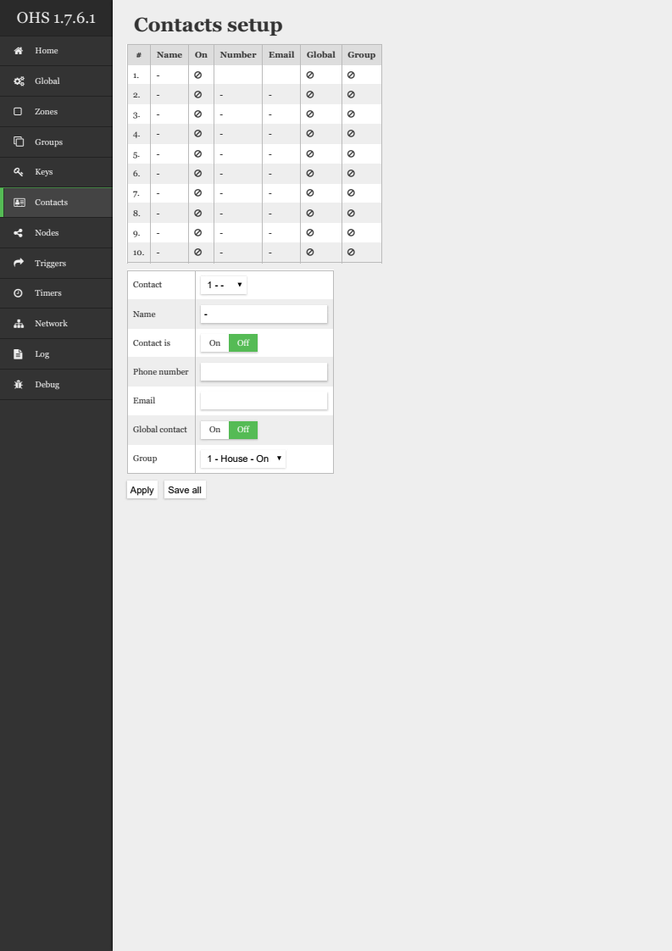
- Contacts Setup – contacts is where anyone that will get a notification is listed. Contacts are edited in the lower table.
  - Contact – select the contact to edit from this list
  - Name – Name of Contact.
  - Contact is – enable the contact by switch this to on.
  - Phone Number – number that the gateway will use to send any SMS messages to and page the contact.
  - Email – email address that the gateway will send alerts to for this contact.
  - Global Contact – set to on to send alerts for all groups to this contact.
  - Group – select the group that the user will recieve alerts for.

Nodes
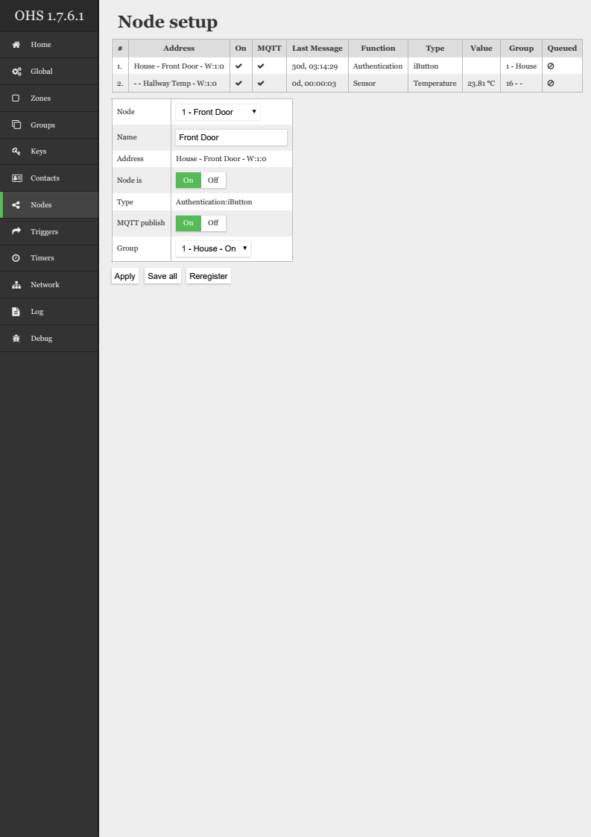
- Node Setup – nodes registered names, mqtt settings and groups are set up here. The nodes are programmed in the lower table.
  - Node – select the data element to program here. Note that a node can send more than one element of data.
  - Name – name your element with a descriptive name here.
  - Address – the element address is displayed here. Note that a 'W' means wired and an 'R' means radio.
  - Node is – set to on to make the element active
  - Type – data type is shown here.
  - MQTT Publish – switch to on to publish the data to MQTT gateway
  - Group – set the group to which this data belongs

Triggers
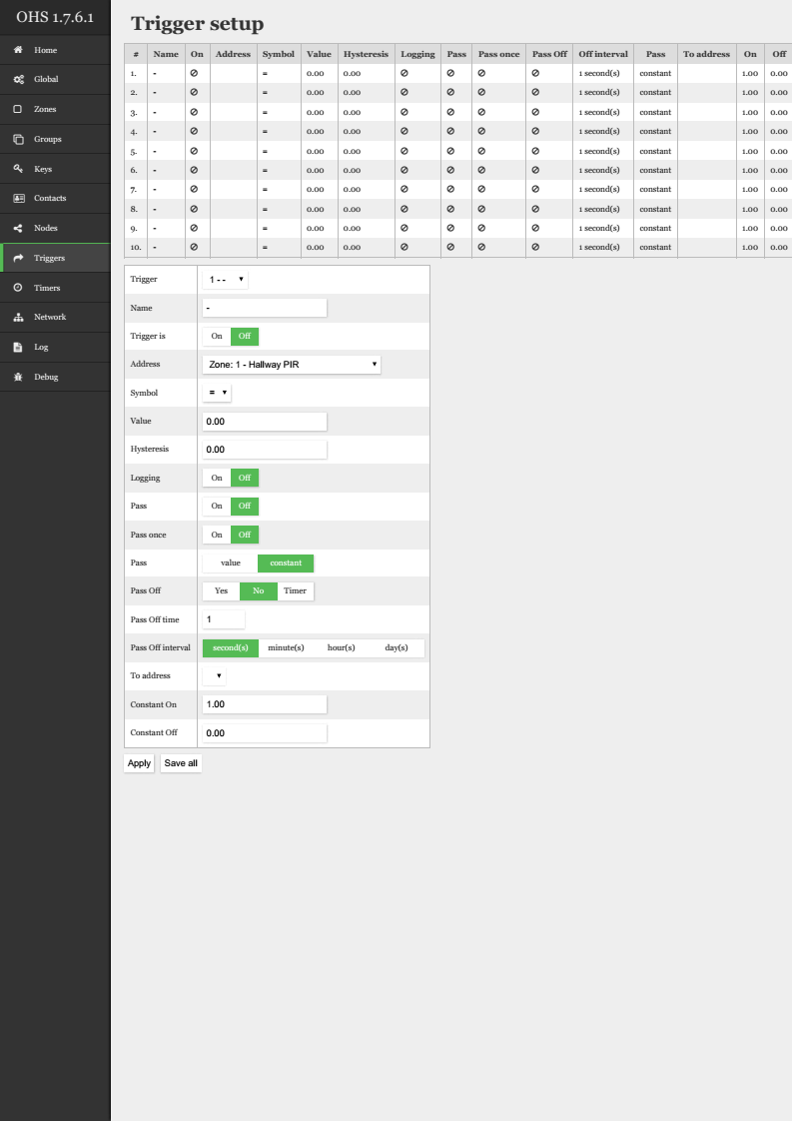
- Trigger Setup – Program triggers to data here. A total of triggers can be programmed. Yes, but only by recombpiling the GW
  - Trigger – select the trigger to program
  - Name – give the trigger a descriptive name. Up to characters long.
  - Trigger is – make the trigger active by switching to on.
  - Address – select the address of the data to monitor. Here are listed all active zones and Sensors registered. So trigger can be zone PIR even if it is not armed. Used for example to switch on light when you enter room.
  - Symbol -
    - = - equal to – sets the output to true when the data is equal to the value.
    - ! - not equal to – sets the output to true when the data is not equal to the value, conversely the output is false when the data equals the value.
    - > - greater than – is true when the data is greater than the value. Note the hysteresis will mean the output will only change when the data exceeds the data + hysteresis.
    - < - less than – is true when the data is less that the value. Note the hysteresis will mean the output will only change when the data exceeds the data + hysteresis.
    - A – always – will pass the data always or always set the output to true.
  - Value – the preset value that the data from address is compared to. For zone = 1 is to be used.
  - Hysteresis – the value of the dead area around the value that the data has to exceed to change the output. This is useful for something like temperature control that would constantly switch on and off too much if the temperature was very close to the value.
  - Logging – set to on to log any triggers going true to the log. This is useful for review and debugging triggers. Also only logged triggers can do alarm as set in Global tab.
  - Pass – passes the data of the address whenever the trigger is true to the 'to address'
  - Pass once – will pass the data to the to address just once when the trigger goes true. Follwing is true for Pass Off: Once the trigger goes false it will reset and send the data again a single time when the trigger nexts goes true.
  - Pass – value or constant – select whether the trigger passes the constant values set in constant true and constant false or the address data. It select whether it passes data from Sensor or Constants defined below. Sometime you just use trigger as router of one sensor to another. For light in room and PIR you set constants, for humidity sensor you pass value to another node that do some other calculation on this real humidity value.
  - Pass off – Once the trigger goes false it will reset and send the data to To address.
  - Pass off time – Delay for pass Off, as example again lights in room, you do not want to turn it off in 1 seconds intervals as you move around. Insted you set delay that is restarted avery time PIR is detected.
  - Pass off time – set the time for the pass value to operate in seconds, minutes, hours or days.
  - To address – the destination address that the data is passed to.
  - Constant On – the constant value the trigger will pass when the argument is true.
  - Constant Off – the constant value the trigger will pass when the argument is false.

Timers
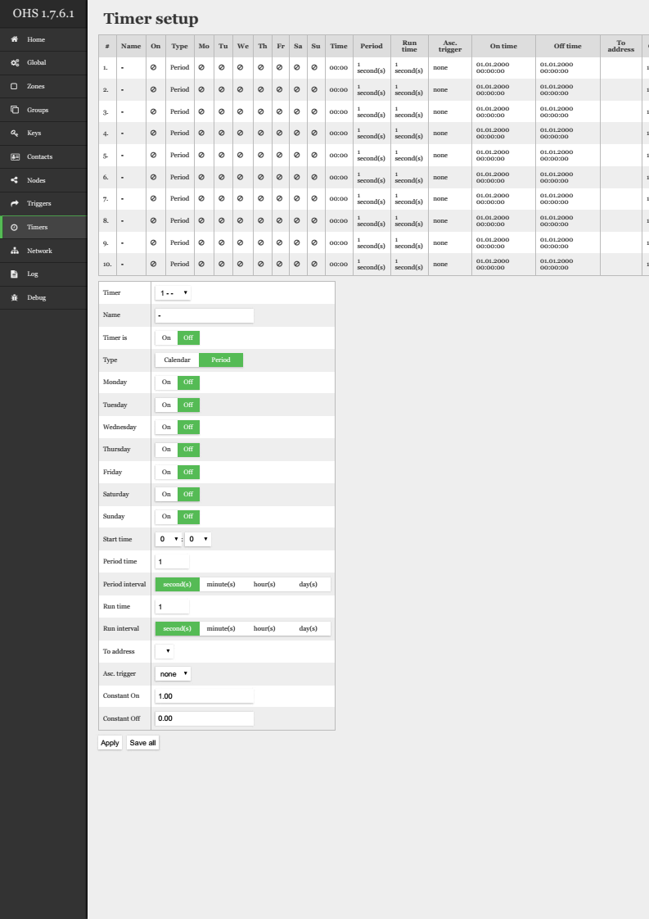
- Timer Setup - set up timers to schedule events. Programming is done in lower table. Perhaps it is misleading, but: Timers are divided to two different kinds. One called Period and other Calendar. The main difference between them is how they handle days of week. Calendar based timer can run only once a day at any given start time you provide. And you can select what day of week it will run.
- Period timer will run repetitively at every period time starting at given start time. Period time can range from 1-255 seconds, minutes, hours or days.
- So some setting is only used for callendar and other for period.
- Both of types of timers have in common run time setting which specify the time between On and Off signal to remote node. It again ranges from 1-255 seconds, minutes, hours or days.
  - Timer – select the timer to program
  - Name – descriptive name for timer
  - Timer is – set on to activate the timer
  - Type – use calender to schedule an event by the time of day and the day of the week. A period timer will pass the on constant to an address for a set time period, switch it to the off constant and wait for an interval time period before switching it back to the on constant for another timer period and so on.
  - Monday – Sunday – set to on to activate the timer on the assigned day. Only for Calendar
  - Start Time – time that the timer will activate for a calendar day, or offset for perion start.
  - Period Time - Interval between periods. Only for Periods.
  - Period Interval – time unit – select from seconds, minutes hours or days.
  - Run Time – time that timer is true
  - Run Interval – time unit – select from seconds, minutes hours or days.
  - To address – the address the output constant off or on is sent to.
  - Asc. Trigger – trigger another timer – use to create a flip flop timer or similar. Associtaed trigger, a condition to run the timer only when such trigger is triggered. Example: Start graden sprinkler, but only when assoc. trigger "humidity" < 80%, thus do not sprinkle when there is raining :)
  - Constant On – the constant value the trigger will pass when the Timer is on. Constant On and Off are the values that are sent to such node at timer start and stop time.
  - Constant Off – the constant value the trigger will pass when the Timer is off. Constant On and Off are the values that are sent to such node at timer start and stop time.
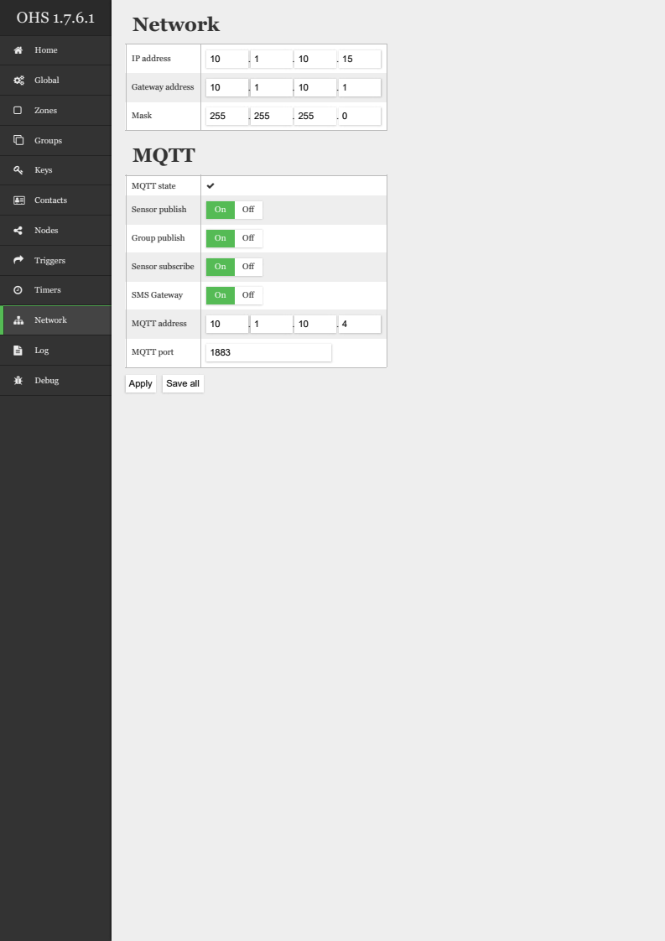

Network
- Network – the gateway is by default configured to use dhcp. To make the web interface for your gateway easier to access either reserve the dhcp lease or set a fixed IP in the table provided.
  - IP address – set an address to match your subnet here.
  - Gateway – the IP address of your router or whatever acts as the gateway on your network. Note – the gateway address is also used as the DNS server address. Make sure your gateway and DNS server addresses are the same.
  - Mask – set a subnet mask that is valid for your network.

- MQTT – the MQTT server is used as gateway to control or monitor sensors or devices on the OHS system. Authentication or SSL to the server is currently not supported. Note that the gateway monitors its network connectivity by the presence off the MQTT server. If no MQTT server is available the gateway will reset the network adapter to try reconnect.
  - MQTT State – the current state of the connection to the MQTT server.
  - Sensor Publish – set to On to publish any sensor data. MQTT address for the address is /OHS/$group name$/Sensor/$sensor name$/$sensor type$/$sensor local number ; $... name$ is variable from OHS configuration
  - Group Publish – set to On to publish the states of groups. MQTT address is OHS/$group name$/state
  - Sensor Subscribe – set to on to subscribe to data for OHS controls. MQTT address is /OHS/In/$sensor type$/$sensor name$/$sensor local number
  - SMS Gateway – Subscribes to any messages that need to be sent via SMS. Allows other systems to use the OHS SMS services to send messages as well. Yes, but not working now as I have accidently deleted the code, without backup :(
  - MQTT Address – the IP address of the MQTT server.
  - MQTT Port – the port of the MQTT server. Default is usually 1883.

Log
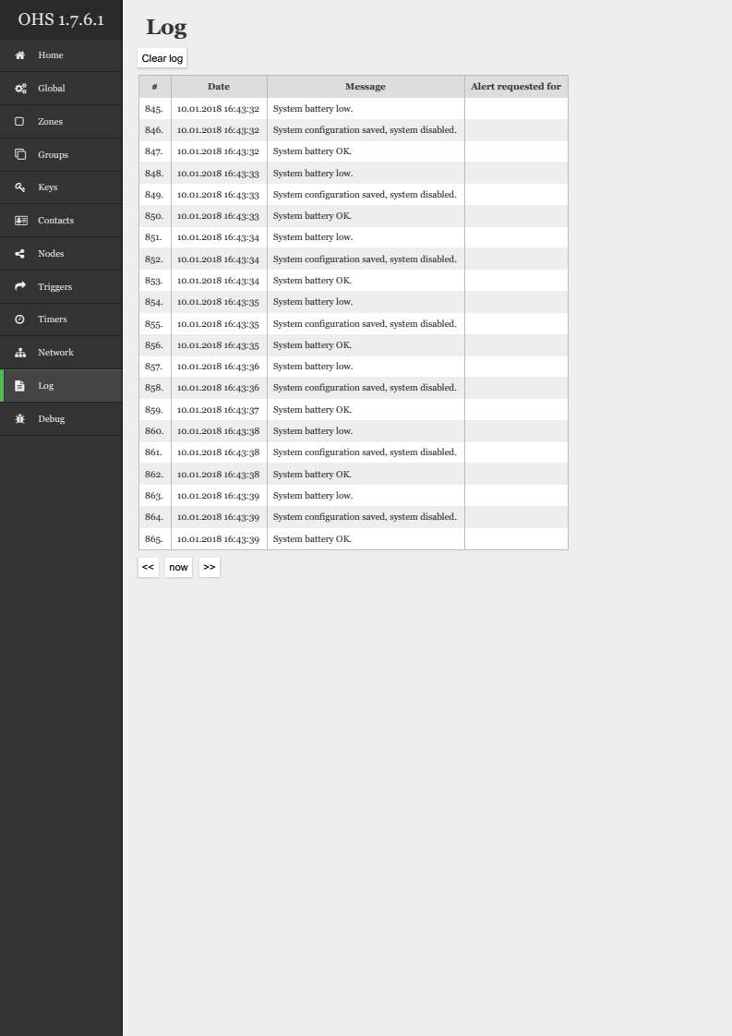
- Clear Log – use to clear the log which will take 4096*5ms around 21 seconds. Basically EEPROM is slow device, and needs time to sync. I may try to speed it up by better utilizing the pages, but it is not often used function.
- Now, <<, >>, - use to navigate between the pages of the log.

